Error: Reference source not found

Version: 1.0.4
DocCode: TOOL-ALL-UG-0001
Date: May 15, 2012


www.spreadtrum.com
Important Notice
Copyright Notice
Copyright © 2010, Spreadtrum Communications, Inc. All rights reserved.
Trademarks
Spreadtrum Communications, Inc. and Spreadtrum Communications, Inc.'s products are exclusively owned by Spreadtrum Communications, Inc. References to other companies and their products use trademarks owned by the respective companies and are for reference purpose only.
Warranty Disclaimer
Spreadtrum Communications, Inc. makes no representations or warranties, either expressed or implied, by or with respect to anything in this document, and shall not be liable for any implied warranties of merchantability or fitness for a particular purpose or for any indirect, special or consequential damages.
Confidentiality
The information contained herein (including any attachments) is confidential. The recipient hereby acknowledges the confidentiality of this document, and except for specific purposes, this document shall not be disclosed to any third party.
About This Document

Purpose
The FontTool User Guide describes the functions of FontTool and how to use it.

Intended Audience

Organization
This document consists of six chapters and is organized as follows.
Chapter | Describes
1 Introduction | The functions, file composition, and running requirements of FontTool.
2 Interface Description | The main interface, toolbar, analysis panels of FontTool.
3 Operation Guide | How to use FontTool.
4 Usage Guide | How to make a font file.
5 Configure file | How to configure INI files.
6 FAQ

Contents
1 Introduction 2
1.1 Functions 2
1.2 File Composition 2
1.3 Running Requirements 2
1.4 Font File Format Spec 2
2 Interface Description 3
2.1 Main User Interface 3
2.2 Glyph Edit Interface 4
3 Operation Guide 6
3.1 Import BDF Files 6
3.2 Import OTF Files 7
3.3 Import DMF Files 9
3.4 Save DMF Files 9
3.5 Save BDF Files 10
3.6 Edit Glyph 10
3.7 Adjust Glyph parameters 10
3.8 Add Font Lib 11
3.9 Remove Font Size 11
3.10 Replace Glyphs with BDF 11
4 Usage Guide 12
5 Configure Files 13
5.1 Add a Char Set 15
6 FAQ 16
6.1 How to import old version DMF files 16

Figures
Figure 2-1 Main interface 2-3
Figure 2-2 Edit font for gray glyphs 2-4
Figure 2-3 Edit font for black and white glyphs 2-5
Figure 3-1 Import BDF files 3-6
Figure 3-2 Import OTF files 3-7
Figure 3-3 Import OTF files with Vector Flag 3-8
Figure 3-4 Advance Setting 3-8

Tables
Table 2-1 Elements description in the main interface 2-3
Table 2-2 Edit font 2-4

Introduction

Functions
The FontTool is used to generate font files for Spreadtrum MMI platform.

File Composition
FontTool consists of the following files:
- FontTool.exe
- FontTool.ini
- Arab.ini
- Devanagari.ini
- Greek.ini
- Han_gbk.ini
- Han_gb2312.ini
- Han_gb18030.ini
- Han_big5.ini
- Latin.ini
- Russian.ini
- Thai.ini

Running Requirements
FontTool runs on Windows 2000, XP, VISTA, Windows7 and etc.

Font File Format Spec
File Format | Description
BDF | Bitmap Distribution Format
TTF | True Type Format（*.ttf）
OTF | Open Type Format（*.otf）
DMF | Spreadtrum Dot Matrix Format （*.lib）

Interface Description

Main User Interface
Figure 2-1 shows the main user interface and Table 2-1 describes the elements in the main interface.
              - Main interface
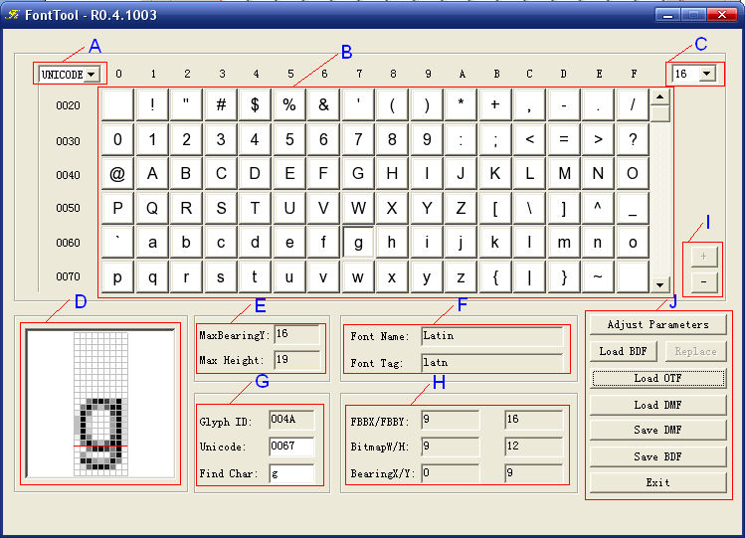
                - Elements description in the main interface
Item | Description
A | Select display order of section B: UNICODE or GLYPHID order.
B | Glyph displaying section; you can select a glyph and it will be displayed in section D.
C | Select current glyphs size.
D | Zoom in the current glyph, and you can double click it and then edit it.
E | Display Max glyph Height and Max Bearing Y of the current glyph size.
F | Current font’s name and tag.
G | Search glyph, only if you select the UNICODE order in Section A.
H | Display the current glyph information:  FBBX/FBBY: character Width and Height including the space round the glyph  BitmapW/H：glyph Width and Height not including the space round the glyph  Xoff/Yoff：base line coordination
I | Function buttons.
J | “+”Merge font lib; “-” remove current font size

Glyph Edit Interface
Double click the section D in main user interface, and then FontTool will show Glyph Edit dialog. Figure 2-1 shows the glyph edit interface for gray glyphs and Figure 2-2 shows the glyph edit interface for black and white glyphs.
              - Edit font for gray glyphs
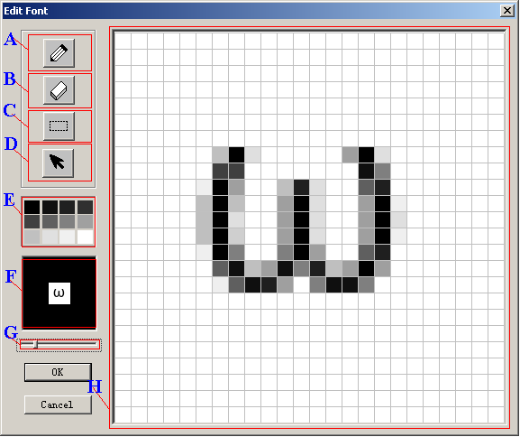

                - Edit font
Item | Description
A | Pen tool. Select it and then draw points in the section H.
B | Erase tool. Select it and then erase points in the section H.
C | Select tool. Select it and then select area and move the area in the section H.
D | Undo tool. Select it and undo the latest operations not more than 5 times.
E | Select color.
F | Display the glyph zoomed in/out in the section H.
G | Zoom in or out the glyph.
H | Glyph edit section.
              - Edit font for black and white glyphs
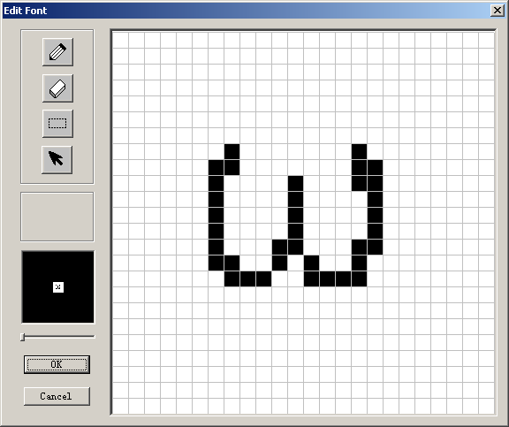

Operation Guide

Import BDF Files
Click the button “Load BDF” in the main user interface and select *.BDF files. Figure 3-1 shows the user interface.
              - Import BDF files
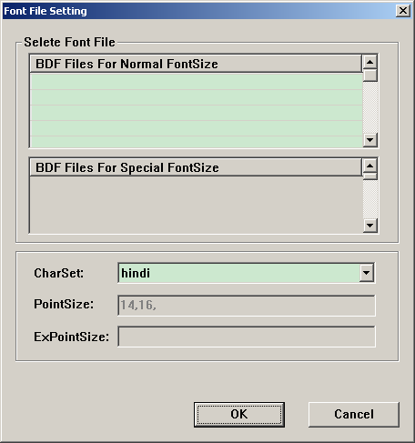
Double click the cell of “BDF Files for Normal FontSize”, and select BDF files. If there are special glyph sizes in “CharSet” configure file, you can select BDF files for special font size. See details in “Configure Files” chapter.

Import OTF Files
Click the button “Load OTF” in the main interface and select *.otf, *.ttf or *.ttc files and set parameters. Figure 3-1 shows the user interface.
              - Import OTF files
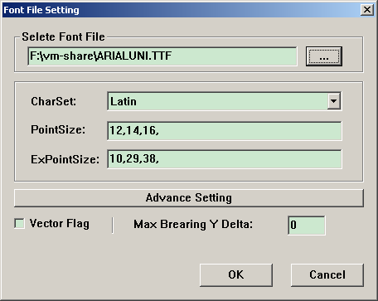
“…” ----Select OTF, TTF or TTC file.
“CharSet” ----Select char set.
“Point Size” ----Input font sizes, if more than one,, using “,” to separate them
“ExPointSize” ---- Input special font sizes, if more than one, using “,” to separate them
“Advance Setting” ----Advance setting, shows in Figure 3-3
“Vector Flag” ----Select vector flag, if select it, FontTool will generate vector font.
“Max Bearing Y Delta” ----Max Bearing Y delta value [-32, 32]

If you select “Vector Flag”, the user interface will change as Figure 3-2.

              - Import OTF files with Vector Flag
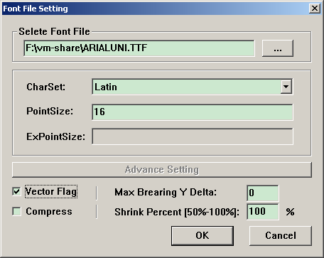
“Shrink Percent [50%-100%]” ----Shrink font height percent [50,100]
“Compress” ----Compress the outline and compound glyph flag
              - Advance Setting
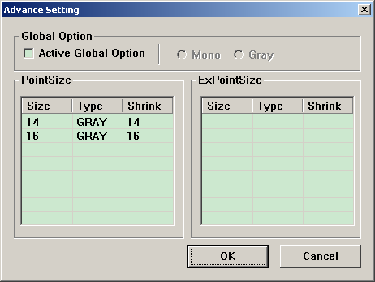
“Active Global Option” ----Active global option: MONO，GRAY
“Mono” ----Set the glyph black and white
“Gray” ---- Set the glyph gray
“Size” ----Font Size
“Shrink” ----Shrink the font size (0, Size ]
Click the “Type” cell to set the font type. Click the “Shrink” cell to set shrink size.
Notes:
“Shrink” size is real font size abstracted from OTF files. Because some glyph height is over the height that we want, and this will cause the problem of MMI display.

Import DMF Files
Click the button “Load DMF” in the main interface and select *.lib files.
Notes:
DMF is a kind of format of Spreadtrum font。.

Save DMF Files
Click the button “Save DMF” in the main interface, and save to “*.lib” files.

Save BDF Files
Click the button “Save DMF” in the main interface, and save to “*.bdf” files.
Notes:
Gray font can not export to BDF files.。.

Edit Glyph
Double click the section D in the main user interface. FontTool will show a dialog as Figure 2-2.
You can copy and paste glyph in the edit dialog interface. Ctrl+C copy, and Ctrl+V paste. Also you can right click in the glyph edit section to show a popup menu, and then select copy and paste menu item.

Adjust Glyph parameters
Click button “Adjust Parameters” to adjust the X/Y delta of glyphs, only if the current font is bitmap font. See Figure 3-1:
              - Adjust Parameters
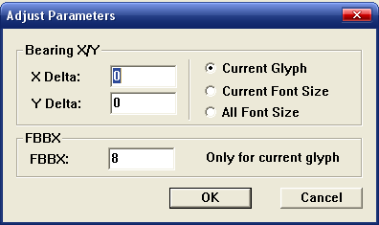
“X Delta” —— X delta, plus value is right and minus value is left
“Y Delta” —— Y delta, plus value is right and minus value is left
“Current Glyph” —— Adjust the current glyph
“Current Font Size” —— Adjust all glyphs of the current font size
“All Font Size” —— Adjust all glyphs of all font size
“FBBX” —— Modify FBBX.

Add Font Lib
Click the button”+” to add another bitmap font lib to the current only if the current font is bitmap (Gray or Mono).

Remove Font Size
Click the button”-” to remove the current font size only if the current font is bitmap (Gray or Mono).

Replace Glyphs with BDF
When loaded a DMF file (*.lib), if it is a bitmap font, you can click the button “Replace” to replace the glyphs of current font size with a BDF file.
Notice:
1. The tool can only replace the Unicode glyphs.
2. The font type must be matched. (Gray or Mono).

Usage Guide
The process of generating a DMF file is as below:
（1）Import OTF/TTF/TTF, BDF or DMF Files.
（2）Adjust glyphs if you need.
（3）Click the button “Save DMF” to save DMF file.
Caution：
If generate bitmap font, you can edit glyphs. But you cannot edit glyphs for vector font.

Configure Files
FontTool contains configure files. See details in chapter 1.
Example of Latin.ini:
[FontInfo]
; Char set name
CharSetName = latin
; Char set tag
; Char set tag is composed not more than 4 ASCII chars.
CharSetTag = latn
; Unicode sector number
UnicodeSectorNum = 19
; Font size
PointSize = 8,10,12,14,16
; Special Unicode glyph sector number
; It must be sub-set of UnicodeSector
SpecialUniSecNum = 3
; Sepecial font size
SpecialPtSize = 40

[PointSizeProperty]
; PointSize = FontType,ShrinkSize
; FontType: 0,Mono; 1, Gray
; ShrinkSize is the real size for loading glyph from OTF File
; Notice: there must be no space round “,” separator
10=1,10
14=1,14
16=1,16
20=1,20

[UnicodeSector]
; Notice: Unicode sector muse be ordered and there must be no space round “,” separator
;sectorNO = unicode-strart,unicode-end
;1=0x0041,0x005A
;2=0x0061,0x007A
1=0x0020,0x007E
2=0x00aa,0x00AA
3=0x00ba,0x00BA
4=0x00c0,0x00D6
5=0x00d8,0x00F6
6=0x00f8,0x0241
7=0x0250,0x02AF
8=0x1d00,0x1D25
9=0x1d2c,0x1D5C
10=0x1d62,0x1D65
11=0x1d6b,0x1D77
12=0x1d79,0x1DBF
13=0x1e00,0x1E9B
14=0x1ea0,0x1EF9
15=0x2071,0x2071
16=0x207f,0x207F
17=0x2090,0x2094
18=0x212a,0x212B
19=0xfb00,0xFB06

[SpecialUnicodeSector]
1=0x0023,0x0023
2=0x002A,0x002B
3=0x0030,0x0039

Add a Char Set
Create a xxx.ini file, and input the font information as above, and save it to the same folder as other INI files.

FAQ

How to import old version DMF files
FontTool uses new format of DMF files from 0.1.001 version and it will not support the format before. But you can use the way to change it to new version format:
Use the old version FontTool to open the “*.lib” file and save it as BDF file. And then use new FontTool open it and save it to DMF file with new format.

